Playground Installation Checklist
You’ve purchased a beautiful and safe playset for your kids. Now for the installation. The Rooster has consolidated installation lessons-learned over the years and summarized them below. Enjoy!

Site prep…

The month before
☐ Layout your playset footprint on grid paper according to the manufacturer's diagram.
☐ Check the grade of your yard so the playset has good drainage (at least 2” per 10’).
☐ Orient the playset to avoid tree roots, retaining walls, in ground sprinklers and other hazards.
☐ Allow at least a 3’ buffer around the playset so the kids can navigate around the equipment.
☐ Avoid getting too close to fence gates or places that need to be maintained with a mower.
☐ Plan access to the site and allow for at least 6’ (gates, fences, landscape, neighbor property).
☐ Plan the type of surface for your play area (rubber mulch, wood mulch, grass, artificial turf). See https://www.roosterrubber.com/homeowners for downloadable manuals.
☐ Plan the type of borders for your play area (rubber timbers, plastic 8”, wood). See https://www.roosterrubber.com/borders for ideas.
☐ Call Rooster Rubber at 816-241-6400 for a quote on materials, installation, or both.
☐ Calculate the quantity of rubber mulch, weed barrier and borders at the Rooster’s mulch calculator: https://www.roosterrubber.com/
☐ Order materials several weeks ahead of time so any special items can be acquired.

The week before installation
☐ Order and stage materials (borders, surfacing, weed barrier, etc.) at the site.
☐ Confirm install date with crew.
☐ Plan to be available so issues can be addressed promptly.
☐ Review installation diagram with installation lead, especially access to the site.
☐
☐

Installation - Site Prep
☐ Layout the borders according to your diagram (use string and stakes to keep a straight line).
☐ Tack down, but only enough to keep in position and allow the weed barrier to slide underneath.

Weed barrier-
☐ Start on the lowest part of the project area and lay down the 1st strip of barrier.
☐ Secure strip to ground with 6” sod staples (3 per square yard, except seams, which are every 15”).
☐ Secure the first strip. Then overlap the next strip by 6” or so, like how roof shingles are arranged.
☐ IMPORTANT! Try to achieve the tightest, smoothest surface as possible (see attached picture).
☐ Extend the barrier underneath the borders.

Borders -
☐ Secure the borders once the weed barrier is down.
☐ Leave an opening so you can maneuver wheelbarrows or other equipment inside the area.

Rubber mulch installation…

With lifting equipment:
☐ Lift the sack using the stirrups on the top.
☐ Position in area where it can be raked out (1 sack per 214 sq ft - 4”; 285 sq ft – 3”).
☐ To open a sack, make 2 vertical slits – 1 on each of 2 sides. Then make horizontal slit near the bottom on those same 2 sides.
☐ Warning: stand back about 3 feet from the sack when making the final cut. The mulch will exit under pressure.
☐ Rake out until level.
☐ Move borders back and secure to the ground.
☐ With garden hose, spray the mulch down to wash paint dust off.

With manual equipment:
☐ Slit sack open – stand back about 3’ so mulch has room to spill out.
☐ Shovel into wheelbarrow and move to the project site.
☐ Rake out until level.
☐ Move borders back and secure to the ground.
☐ With garden hose, spray the mulch down to wash paint dust off.

Materials needed
☐ Rubber mulch – Black, Brown, Redwood, Green, Blue
☐ Depth (3” for Residential, 6” Public, 2” Landscape)
☐ Weed barrier & staples (12.5’ and 15’ width rolls).
☐ Borders -protect your investment (Recycled plastic 4’x 8”/12”; Rubber timbers (6” x 92”; black, brown, red).
☐ Mats for swings, slides, monkey bars (4’x 6’; 3’ x 3’; 2’ x 3’).
☐ Installation (call 816-241-6400 for site visit).
☐ Delivery (you can pick up but let us deliver and save the wear and tear on you and the vehicle).

Site drainage tips.
☐ 1-2% grade provides sufficient drainage.
☐ For larger sites, consider a French drain.

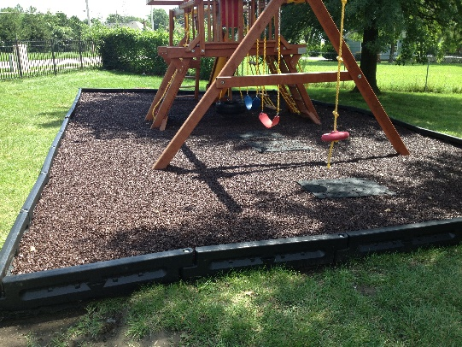
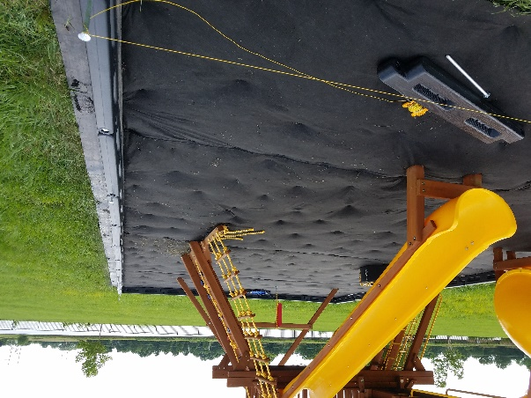
Examples of proper weed barrier installation.

